Accuracy
Accuracy measures the proportion of correctly classified instances (both true positives and true negatives) out of the total instances. It is computed as:
$Accuracy = \frac{TP + TN}{TP + TN + FP + FN}$. | (4)
Sensitivity
Sensitivity quantifies the models’ ability to correctly identify positive instances. It is calculated as:
$Sensitivity = \frac{TP }{TP + FN}$. | (5)
Specificity
Specificity measures the models’ ability to correctly identify negative instances. It is computed in the following way.
$Specificity = \frac{TN }{TN + FP}$. | (5)
Precision
Precision assesses the proportion of true positive predictions among all positive predictions. It is given by:
$Precision = \frac{TP }{TP + FP}$. | (5)
NPV
NPV quantifies the proportion of true negative predictions among all negative predictions. It is calculated as:
$NPV= \frac{TN }{TN + FN}$. | (5)
F1 Score
The F1 score is the harmonic mean of precision and sensitivity, providing a balanced measure of the models’ performance. It is computed as:
$F1 score = 2×\frac{Precision × Sensitivity }{Precision + Sensitivity}$. | (5)

Supplemental Figures
Supplemental Table 1. Effect Sizes and Marginal Means: Main effects and interactions for classification outcomes in conditions with DIF that is not visible in the TIF..
 | Partial η²
 | Accuracy | Sensitivity | Specificity | Precision | NPV | F1 Score
Method | 0.08 | 0.21 | 0.35 | 0.21 | 0.21 | 0.08
Sample Size ($N$) | − | − | 0.07 | − | − | −
Number of Items | 0.09 | − | − | − | − | 0.08
Prevalence ($p$) | 0.10 | 0.09 | 0.10 | 0.30 | 0.09 | 0.24
DIF Rate (d) | 0.12 | 0.07 | − | − | 0.07 | 0.11
b Strength (b) | 0.12 | 0.07 | − | − | 0.07 | 0.12
$p ×$ Method | − | − | 0.18 | − | − | −
d $×$ b | 0.15 | 0.09 | − | − | 0.09 | 0.14
d $×$ Method | 0.07 | − | − | − | − | 0.06
b $×$ Method | 0.09 | 0.07 | − | − | 0.07 | 0.09
d $×$ Method $×$ b | 0.12 | 0.08 | − | − | 0.08 | 0.11
 | Marginal Means (SD)
 | Accuracy | Sensitivity | Specificity | Precision | NPV | F1 Score
IRT
Full Sample | .94 (.04) | .94 (.05) | .95 (.05) | .99 (.02) | .94 (.05) | .96 (.03)
Reference Group | .94 (.06) | .93 (.08) | .97 (.03) | .99 (.01) | .93 (.08) | .96 (.06)
Focal Group | .95 (.04) | .97 (.03) | .91 (.14) | .98 (.04) | .97 (.03) | .97 (.03)
RF_{Class}
Full Sample | .96 (.02) | .97 (.02) | .89 (.06) | .97 (.01) | .97 (.02) | .97 (.01)
Reference Group | .96 (.02) | .96 (.02) | .91 (.07) | .98 (.01) | .96 (.02) | .97 (.01)
Focal Group | .96 (.02) | .98 (.02) | .86 (.12) | .97 (.03) | .98 (.02) | .97 (.02)
Note: Partial η² = effect size on the give outcome; DIF = differential item functioning; TIF = test information function; FR Ratio = the ratio of the focal group sample size to the reference group sample size. Effect sizes < 0.06 (medium effect; Cohen, 2009) were omitted. In such cases when a main effect or interaction was not found to be influential (effect sizes < 0.06) on any classification measure, it was omitted from this table for simplicity. All results from the random forest approaching using probabilities were not included in the ANOVA sample, as they were shown to perform notably worse than other approaches upon visual inspection.

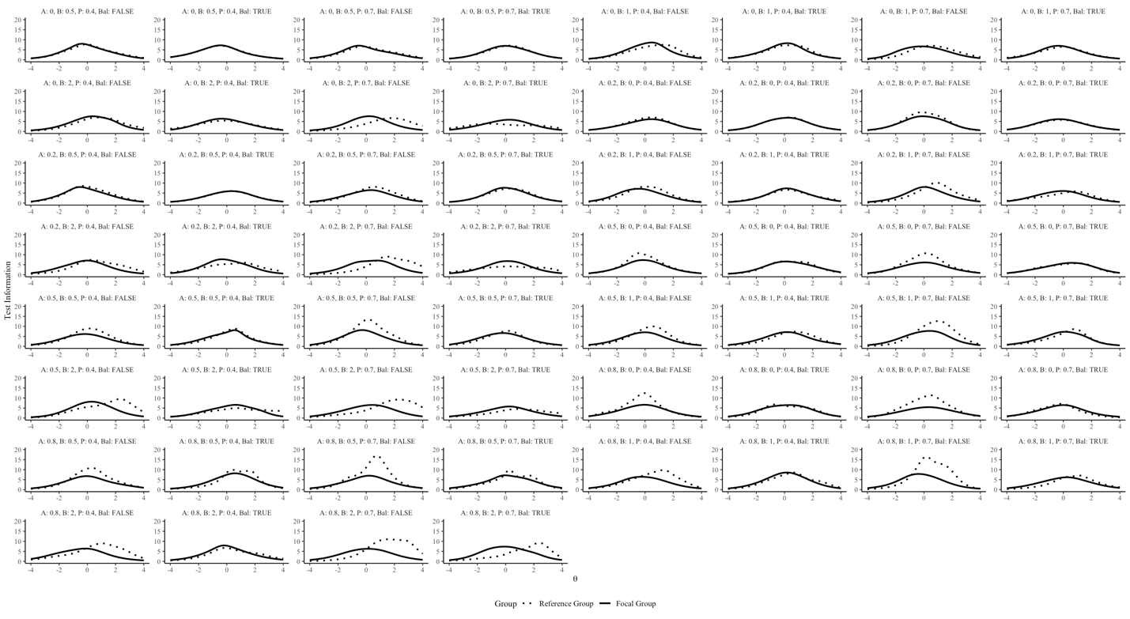
Supplemental Figure 1. Comparison of Test Information Functions (TIFs) between reference and focal groups across different Differential Item Functioning (DIF) conditions. The facets display results for varying DIF effect types (discrimination [A], difficulty [B], and both), DIF effect magnitudes (A: 0.2, 0.5, 0.8; B: 0.5, 1, 2), DIF proportions (P: 0.4, 0.7), and DIF balance conditions (balanced and unbalanced). Solid lines represent the TIF for the reference group, while dotted lines represent the TIF for the focal group. The horizontal axis represents theta (θ), or the latent ability scale, and the vertical axis represents the level of test information. Each panel corresponds to a unique combination of DIF parameters, demonstrating how different DIF conditions affect the TIF of the focal group compared to the reference group.

